Online Construction Handling

**MUDASSIR YASIN**

**ABBAS AHMAD**



DEPARTMENT OF COMPUTER SCIENCES COMSATS UNIVERSITY ISLAMABAD, ATTOCK CAMPUS – PAKISTAN

SESSION 2017-2021

Online Construction Handling

*Undertaken By:*

**ABBAS AHMAD**

CIIT/FA17-BSE-024/ATK

**MUDASSIR YASIN**

CIIT/FA17-BSE-002/ATK

Supervised By:

**MA’AM MEHREEN WAHAB**

A DISSERTATION SUBMITTED AS A PARTIAL FULFILLMENT OF THE REQUIREMENTS FOR THE DEGREE OF BACHELOR OF SCIENCE IN SOFTWARE ENGINEERING

DEPARTMENT OF COMPUTER SCIENCES COMSATS UNIVERSITY ISLAMABAD, ATTOCK CAMPUS – PAKISTAN

SESSION 2017-2021

**UNDERTAKEN**

We certify that this is my/our own work. The work has not, in whole or in part, been presented elsewhere for assessment. Where material has been used from other sources it has been properly acknowledged. If this statement is untrue, we acknowledge that we will have committed an assessment offence and shall be liable to punishable action under the plagiarism rules of HEC.

Abbas Ahmad Mudassir Yasin

FA17-BSE-024 FA17-BSE-002

Dated: Dated:

Submission Form for Final-Year

PROJECT REPORT

**2**

**NUMBER**

**OF MEMBERS**

**Online Construction Handling**

**TITLE**

**PROJECT ID**

**CHECKLIST:**

**Miss Mehreen Wahab**

**SUPERVISOR NAME**

|  |  |  |
| --- | --- | --- |
| **MEMBER NAME** | **REG. NO.** | **EMAIL ADDRESS** |
| Abbas Ahmad | FA17-BSE-024 | [ahmadkhanzz003@gmail.com](mailto:fizaqaseem@gmail.com) |
| Mudassir Yasin | FA17-BSE-002 | [mudassar.yasin802@gmail.com](mailto:aqsaamanat371@gmail.com) |

Number of pages in this report

We have enclosed the soft-copy of this document along-with the codes and scripts created by ourselves

+

**YES / NO**

Our supervisor has attested the attached document **YES / NO**

**We confirm to state that this project is free from any type of**

**plagiarism and misuse of copyrighted material**

Supervisor’s Signature

**MEMBERS’ SIGNATURES**

**YES / NO**

**FINAL APPROVAL**

Certified that we have read this project report submitted by Mr. Abbas Ahmad (FA17-BSE-024) and Mr. Mudassir Yasin (FA17-BSE-002) and it is, in our judgment, of sufficient standard to warrant its acceptance by Department of Computer Science, COMSATS University Islamabad, Attock Campus, for the BSSE degree.

***Committee:***

1. External Examiner

signature

1. Supervisor

signature

3. Head of the Department

signature

*Every challenging work needs self-effects as well as guidance of elders especially those who were very close to our hearts.*

*My humble efforts I dedicate to my sweet and loving.*

ALLAH

*My creator my strong pillar, my source of inspiration, wisdom, knowledge and understanding.*

Father and mother

*Whose affection, love, encourage and prays of day and night make me able to get such success and honor.*

Teachers

***Along with all hard working and respected teachers***

In the name of ALLAH, the most kind and the most merciful.

We would like to thank our parents who kept backing us up in all the times, both financially and morally. We would also like to thank **Ma’am Mehreen Wahab** forher guidance and encouraging us to work hard and smart. We have found her very helpful while discussing the optimization issues in this dissertation work. We would also like to thank our parents who kept backing us up in the all the times both financially and morally.

We are grateful to the ALLAH Almighty who provides all the resources of every kind to us so that we make their proper use for the benefit of mankind. May He keep providing us with all the resources, and the guidance to keep helping humanity.

Now a days online shopping is becoming popular. Different websites are available that serve people.

This is an online construction handling web application, which is being designed to facilitate the customer and the contractor as well. This web application helps the people in any kind of construction i-e building houses, shops etc. Customers can find construction materials or contractors from the market but the main problem is that they sometimes don’t have time to do that, also some customers don’t have idea about the prices of materials and idea about contractors (whether they can trust him or not). Our web application also facilitates the contractor. He can easily find customer here on our website, he can bid on different ads which the customer posted. Sometimes the contractor needs materials and he do not have idea where to get them, so he can find those materials easily on our website because there it will be posted by many of the users.

With this Web application, the customer can avail of all the services of his interest at the doorstep. On the other hand, the contractor will not have to struggle much for marketing his goods/services. So many of the issues can be resolved by using this web application.

# Table of Contents

1. Introduction 2
   1. Brief 2
   2. Relevance to course modules 3
      1. Report Writing Skills 3
      2. Software Engineering 3
      3. Web Engineering 3
      4. HCI 3
   3. Project background 3
   4. Literature Review 3
      1. Analysis from Literature Review 4
   5. Methodology 4
      1. Rationale behind Selected Methodology 5
2. Problem Definition 6
   1. Problem Statement 7
   2. Proposed Solution 7
   3. Deliverables and Development Requirements 7
   4. Development Requirements 7
      1. Tools and technologies 8
3. Requirement Analysis 9
   1. Functional requirements 10
      1. FR-01 Administrator 10
      2. FR-02Registration 11
      3. FR-03 Login 12
      4. FR-4 Web Admin Panel 12
      5. FR-05 Posting 13
      6. FR-06 Chat 14
      7. FR-08 Delivery Confirmation 14
   2. Non-Functional Requirements 15
      1. NFR-01 Reliability 15
      2. NFR-02 Security 15
      3. NFR-03 Availability 15
      4. NFR-04 Robustness 15
         1. Detail Admin Use Case Diagram 16
         2. Detail User Use Case Diagram 28
4. Design and Architecture 31
   1. Architecture Overview 32
   2. Data Modeling (Diagram) 32
      1. Data Flow Diagram 32
      2. Activity Diagram 34
         1. Admin Activity Diagram 35
         2. User Activity Diagram 36
      3. Class Diagram 37
      4. ERD Diagram 38
5. Implementation 39
   1. Tools 40
      1. XAMPP 40
      2. MYSQL 42
      3. Sublime text 43
   2. Development Stages for web portal 44
      1. Sign up 44
      2. Login Page 46
      3. Forgot Password 47
      4. Home page 47
      5. About Us 49
      6. Contact Us 49
      7. Top constructor page 50
      8. Customer Request 52
      9. Send Order 53
      10. View Projects 53
      11. Contractor Account 55
      12. Admin Login 56
      13. Contractor Dashboard 57
      14. Put Request 57
      15. Orders 59
   3. Implementation of rating 60
      1. Getting Ratings from the users 60
      2. Store rating in the database tables 61
6. System Testing 63
   1. Unit Testing 64
   2. System Testing 64
7. Conclusion and Future Work 69
   1. Future Work 70
      1. Website 70
8. References 71

**Table of Figures**

Figure 5- 1 XAMPP Control Panel 41

Figure 5- 2 MySQL Database 42

Figure 5- 3 Sublime 43

Figure 5- 4 Sign Up 45

Figure 5- 5 Login 46

Figure 5- 6 Forgot Password 47

Figure 5- 7 Homepage 48

Figure 5- 8 About us 49

Figure 5- 9 Contact Us 50

Figure 5- 10 Top Constructor page 51

Figure 5- 11 Customer Request 52

Figure 5- 12 Send Order 53

Figure 5- 13 View Projects 54

Figure 5- 14 Contractor Account 55

Figure 5- 15 Admin Login Page 56

Figure 5- 16 Contractor Dashboard 57

Figure 5- 17 Put Request 58

Figure 5- 18 Order 59

Figure 5- 19 Getting rating from user 60

Figure 5- 20 Stored Rating in database 61

List of Tables

Table 3- 1 Administrator 10

Table 3- 2 Registration 11

Table 3- 3 Login 12

Table 3- 4 Web Admin Panel 12

Table 3- 5 Posting 13

Table 3- 6 Chat 14

Table 3- 7 Rating 14

Table 3- 8 Delivery Confirmation 14

Table 3- 9 Login Use Case 16

Table 3- 10 Project Management Use Case 17

Table 3- 11 Edit Blogs Use Case 18

Table 3- 12 Delete User Use Case 19

Table 3- 13 Update Use Case 20

Table 3- 14 Add Blogs Use Case 21

Table 3- 15 Dashboard Use Case 22

Table 3- 16 View Messages Use Case 24

Table 3- 17 User Sign Up Use Case 28

Table 3- 18 User Login Use Case 28

Table 3- 19 Explore Services Use Case 29

Table 3- 20 My Account Use Case 30

# Chapter 1 Introduction

## 1 Introduction

With the advancement in internet technology, almost every department uses their own management system to run business easily and effectively. Construction also becomes a very popular business in Pakistan. Customers face problems dealing with the contractors. In order to overcome this problem, we propose a solution of online construction handling which is an Online Construction Management System. Our project is a web based so everyone can access it through internet. System incorporates buyers and sellers. Anyone who interested in construction or giving the services of construction will register through system and all the functionalities will be available on our platform. Construction houses, apartments, shops on our platform will encourage customers to look at contractors and services in which they are interested in. If a customer wants to avail the services of contractors, he/she can simply add a post in which he will provide information about what he wants on the website. To control all the activities in the website, admin panel in our system responsible of controlling customers, contractors and construction blogs. Our system makes a profile of each user.

## Brief

This is an online construction handling web application, which is being designed to facilitate the customer and the contractor as well. It can help people in construction houses, shops etc. The physical construction work is good but sometimes many people don’t have time to go and search for the items they need. It can also facilitate contractor. Sometimes the contractor doesn’t have enough sources to fulfill his needs. So, the contractor can use our web application to save his time and fulfil his needs.

## Relevance to course modules

In this section, we discuss some of our courses in program that helps us making this project.

## Report Writing Skills

We studied subject named report writing skills. Through this subject we learn that how to format document like formal format for documentation as 12 size for text and 14 for headings, through which format we can write the legal document, how to format tables graphs and diagrams.

## Software Engineering

We studied software engineering that help how we start to make our final year project by 5 phases of se that is planning implementation testing coding. Through this subject we able to make use case diagrams, data flow diagram, activity, sequence diagram.

## Web Engineering

Web engineering has a huge role in our project. By studying this subject, we can make our final year project web based. We understand how to make web pages, make database, and connect web pages with database.

## HCI

In this subject we studied the interaction between human and computer that is middle thing between computer and which is interface. We studied how to make interface of any application. We learn how to human interact with computer using graphic user interface.

## Project background

As the world is now the “World of Internet” and everything is now available within the home to everyone. So, leading this concept, we aim to develop a system where every user will have the access of available production work form their homes in Pakistan. Also, any user can construct any project related to construction through our system without having to go outside. Any user will have to register into our system for the buying of material and hiring contractor. Users can also search any contractor who is registered to our system.

## Literature Review

Creating a web application that will meet the needs of all our construction and will do at home. And it will be our endeavor that we will make this app as effective that in the shortest possible time. In this web application we focused on best quality and reasonable prices. It is our aim to save the time of both the customer and contractor.

## Analysis from Literature Review

In this section, we will highlight some of the previous application that already in the market compare it with our web application. Amazon is the largest trading platform in the world. Where you can buy any goods such as cloths, home appliances etc. low prices across the world. Earths biggest selection of books, music, electronics etc.

Gear best app has 1000+ best stores product categories. And have any other options as such money back guarantee, delivery from warehouses, one year warranty etc.

Ali Baba is one of the leading shopping apps. Where you can buy and supply the goods across the countries. You find the quality products at low prices.

.

## Methodology

This project is built in incremental fashion as shown in figure. Thus, Online Construction Handling is built using incremental model by adding small parts to complete entire task. It is software development life cycle model where projects/system is designed, built and tested incrementally. Increment means “a little more is added each time” until the product is finished. This model is a combination of Waterfall Model with the philosophy of prototyping. This project is divided into smaller number of increments based on requirement priority

. 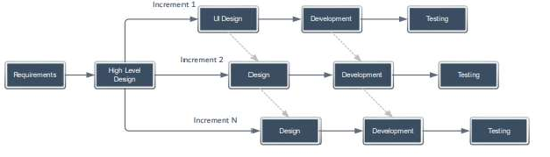

**Figure 1- 1** Incremental SDLC

## Rationale behind Selected Methodology

Our project contains many modules, so we implement each module in a single increment. Characteristics of Incremental SDLC are

* + - 1. Project is divided into smaller portion.
      2. First of all, we make prototype than final system
      3. Firstly, we handle highest priority requirements.

# Chapter 2 Problem Definition

## Problem Definition

## Problem Statement

When a person wants to construct a building, shop or a house etc. he needs good quality and quantity of material. He also wants to save his time and less efforts to do these kinds of works. Some customers do not know about the construction projects how are they done whom to contact etc. Some customers do not communicate well in face to face. Some having time issues. Sometimes they do not find suitable contractors who can do their projects. There are a lot of problems which a customer face.

On the other hand, we provide contractors a platform on which they can offer their services and get projects online.

## Proposed Solution

We aim to provide a system which helps customer and contractor to communicate with each other.

By using our web application many problems will be solved because if any person needs construction work, he can easily find reliable contractor and valuable work. He can easily hire any contractor who can fulfil their requirement and can do his project for him.

By using that web application contractor also reduced a lot of his burden. He will just go to the web application and find some projects. when he finds a project of his interest, he can accept the request of customer. He can easily contact the customer.

## Deliverables and Development Requirements

When we launch our website. Users visit our website they must have a strong internet connection. Through the internet they can easily visit the website and know about the features of website.

While developing the website. We used sublime and bootstrap for developing our webpages attractive and clear.

## Development Requirements

The requirements for our project are Ram 4GB as well as SSD 256 GB also 64-bit Intel or AMD dual-core processor (20k).

## Tools and technologies

#### Tools

* + - * Star uml
      * Sublime text
      * Xampp.

#### Technology

* + - * HTML
      * CSS
      * Php
      * JavaScript
      * Bootstrap

# Chapter 3 Requirement Analysis

## Requirement Analysis

In this chapter we discuss the use case diagrams and functional and nonfunctional requirements. In Use case diagram we can make graphically representation and interaction with our environment of our system and also, we make detailed use case diagram with every part of diagram we can write the detail of every part. In functional requirement we write what our system is basically do. So according to our website it is an online construction handling which handles construction matters. In non-functional requirements we can write requirements that are not compulsory but it can enhance our website productivity and effective.

## Functional requirements

As the name suggests, function means those requirements that a system perform operation on a specific situation. An operation and function are performed as a specific set of behavior between outputs and inputs. Functional requirements involve technical details, calculations, logic, processing, and data manipulation of a system.

## FR-01 Administrator

### Table 3- 1 Administrator

|  |  |
| --- | --- |
| **Name** | **FR-01 Administrator** |
| **Summary** | Administrator must provide the information of construction, contractors and customer. |
| **Rationale** | To keep records consistence. |
| **Requirements** | 1. Administrator can update the system to meet the requirements. 2. Administrator can access and handle customers account and product description like quantity, price etc. |

## FR-02Registration

**Table 3- 2 Registration**

|  |  |
| --- | --- |
| **Name** | **FR-02 Registration** |
| **Summary** | User must register him/herself to see the functionalities of online construction handling. |

|  |  |
| --- | --- |
| **Rationale** | To keep the data of each user separately. |
| **Requirements** | 1. User will enter your information that are required like name, email address, user type and password to register him/her in this app. 2. Click Register button |

Requirement Analysis

## FR-03 Login

### Table 3- 3 Login

|  |  |
| --- | --- |
| **Name** | **FR-03 Login** |
| **Summary** | User must login to enter Online Construction handling. |
| **Rationale** | To keep a trace of individual user activities and to store them for future  use. |
| **Requirements** | 1. User will enter his/her email address and password in the field. 2. Click Login button |

## FR-4 Web Admin Panel

**Table 3- 4 Web Admin Panel**

|  |  |
| --- | --- |
| **Name** | **FR-04 Web Admin Panel (POS System)** |
| **Summary** | Admin can access the webpage. |
| **Rationale** | To keep the admin informed of the orders placed and some setting for  the website. |
| **Requirements** | 1. Web portal only for Admin. 2. Admin can handle the orders of users/clients. |

## FR-05 Posting

**Table 3- 5Posting**

Requirement Analysis

|  |  |
| --- | --- |
| **Requirements** | 1. Customer places a post on posting bidding page. 2. User(contractor) will interact by clicking on the post. 3. User(contractor) will be shown the post info, so he can place a bid. |

|  |  |
| --- | --- |
| **Name** | **FR-05 Posting** |
| **Summary** | Post must be placed on a website. |
| **Rationale** | To keep the data of each user will secure and separate by others. |

Requirement Analysis

## FR-06 Chat

### Table 3- 6 Chat

|  |  |
| --- | --- |
| **Name** | **FR-06 Chat** |
| **Summary** | User can chat with the contractor as soon as he assigns the project. |
| **Rationale** | To keep the data of each user’s chat separately. |
| **Requirements** | 1. User will be facilitated to chat. 2. User can assign project to the contractor to start chat. |

* + 1. **FR-07 Rating**

**Table 3- 7 Rating**

|  |  |
| --- | --- |
| **Name** | **FR-07 Rating** |
| **Summary** | Multiple customers can rate contractors. |
| **Rationale** | To keep the record of each user in each session. |
| **Requirements** | 1. User will be facilitated to view the contractor. 2. User can then manage to rate the contractor. |

## FR-08 Delivery Confirmation

**Table 3- 8 Delivery Confirmation**

|  |  |
| --- | --- |
| **Name** | **FR-08 Delivery Confirmation** |
| **Summary** | Deliver the materials to the location. |
| **Rationale** | To deliver the materials to the location given by user. |
| **Requirements** | 1. Customer will confirm the order. 2. Admin will verify the order details (Address etc.) 3. Customer will pay on delivery. |

## Non-Functional Requirements

Requirement Analysis

Non-functional requirements are those requirements that take part with functional requirements to help and define the system quality with respect to the following parameter from NFR-01 to NFR- 04.[3]

## NFR-01 Reliability

* + - * The proposed system which the developer designs is reliable as it efferently with users. Secure access of confidential data.

## NFR-02 Security

Security constraints are as follows

* + - * User must enter valid email address.
      * User must enter Address that is valid.
      * User data cannot be shared with any third party.
      * After login, user states are maintained.
      * Session will expire for user after logout.

## NFR-03 Availability

Server is available of any time. Availability will be provided if there is an internet connection.

## NFR-04 Robustness

* + - * System cannot lose users information like project, customer and contractor details and purchasing summary etc.

## 3.3.1.1 Detail Admin Use Case Diagram

### Table 3- 9 Login Use Case

|  |  |
| --- | --- |
| **Use case name** | **Login** |
| **Actor** | Admin |
| **Summary** | Admin can login to the system. |
| **Pre-condition** | Admin should be in the login page.  Admin must have valid email address. Admin record must be in the database. |
| **Post-condition** | Admin will redirect to the dashboard page. |
| **Extend** | Nil |
| **Normal course** | 1. Write Web URL. |
| **of events** | 2. Click on login. |
|  | 3. Enter Credentials |
|  | 4. Click on login button to proceed. |

**Table 3- 10 Projects and materials Management Use Case**

|  |  |
| --- | --- |
| **Use case name** | **Project Management** |
| **Actor** | Admin |
| **Summary** | Admin can manage projects, materials and other info in system. |
| **Pre-condition** | Admin should be in the projects page.  Admins navigate through the functionalities. |
| **Post-condition** | Material or projects added updated etc. |
| **Extend** | Add, Update, View, Delete |
| **Normal course** | 1. Go to the materials or categories page. |
| **of events** | 2. Click on Add/Update categories. |
|  | 3. Enter credentials. |
|  | 4. Click on Add/Update to proceed. |

**Table 3- 11 Edit Blog Use Case**

|  |  |
| --- | --- |
| **Use case name** | **Edit Blog** |
| **Actor** | Admin |
| **Summary** | Admin edit blog in the system. |
| **Pre-condition** | Admin must be login to the system.  Admin should be in the edit blog page. |
| **Post-condition** | Admin will be redirected to the edit blog. |
| **Extend** | Nil |
| **Normal course of events** | 1. Click on edit blog. 2. Edit Blog page will be displayed. |

**Table 3- 12 Delete user Use Case**

|  |  |
| --- | --- |
| **Use case name** | **View Product** |
| **Actor** | Admin |
| **Summary** | Admin view user in the system. |
| **Pre-condition** | Admin must be login to the system.  Admin should be in the user page. |
| **Post-condition** | Admin will be redirected to the delete page of user. |
| **Extend** | Nil |
| **Normal course of events** | 1. Click on user delete button. 2. User will be deleted from the page. |

**Table 3- 13 Update Use Case**

|  |  |
| --- | --- |
| **Use case name** | **Update** |
| **Actor** | Admin |
| **Summary** | Admin can update product information in the system. |
| **Pre-condition** | Admin must be login to the system.  Admin should be in the product update page. |
| **Post-condition** | Admin will be redirected back to products updated page. |
| **Extend** | Nil |
| **Normal course of events** | 1. Go to Product Update. 2. Enter all the fields that Admin want to update. 3. Click update button. |

**Table 3- 14 Add Blogs**

|  |  |
| --- | --- |
| **Use case name** | **Add** |
| **Actor** | Admin |
| **Summary** | Admins add blogs to the system. |
| **Pre-condition** | Admin must be login to the system.  Admin is in the Add blog page. |
| **Post-condition** | Admin will be redirected to the blog add page. |
| **Extend** | Nil |
| **Normal course of events** | 1. Admins go to the Add blog page. 2. Enter blog specification. 3. Click on Add blog button. |

**Table 3- 15 Dashboard Use Case**

|  |  |
| --- | --- |
| **Use case name** | **Dashboard** |
| **Actor** | Admin |
| **Summary** | Admin can see the dashboard of the system. |
| **Pre-condition** | Admin should be in the dashboard page  Admin can view all the pages from dashboard page. |
| **Post-condition** | Materials added or info updated. |
| **Extend** | Nil |
| **Normal course of events** | 1. After login can see the dashboard. 2. Click on product, orders, users page. |

**Table 3- 16 Sign Up Use Case**

|  |  |
| --- | --- |
| **Use case name** | **Sign Up** |
| **Actor** | User |
| **Summary** | User can Sign up to the system. |
| **Pre-condition** | User should be in the sign-up page.  User must have valid email address. User record must not be in the database. |
| **Post-condition** | User will redirect to the home page. |
| **Extend** | Nil |
| **Normal course of events** | 1. Go to sign up UI. 2. Enter credentials. 3. Click Sign Up button. |

**Table 3- 17 View Messages Use Case**

|  |  |
| --- | --- |
| **Use case name** | **View Messages** |
| **Actor** | Admin |
| **Summary** | Admin view users’ messages that are placed by user in the system. |
| **Pre-condition** | Admin must be login to the system.  Admins are in the view messages page. |
| **Post-condition** | Admin are redirected to the view messages page. |
| **Extend** | Nil |
| **Normal course of events** | 1. Go to user messages page. 2. View user’s messages on user messages page. |

## 3.3.2.1 Detail User Use Case Diagram

**Table 3- 18 Sign Up Use Case**

|  |  |
| --- | --- |
| **Use case name** | **Sign Up** |
| **Actor** | User |
| **Summary** | User can Sign up to the system. |
| **Pre-condition** | User should be in the sign-up page.  User must have valid email address. User record must not be in the database. |
| **Post-condition** | User will redirect to the home page. |
| **Extend** | Nil |
| **Normal course of events** | 1. Go to sign up UI. 2. Enter credentials. 3. Click Sign Up button. |

**Table 3- 19 User Login Use Case**

|  |  |
| --- | --- |
| **Use case name** | **Login** |
| **Actor** | User |
| **Summary** | User can login to the portal. |
| **Pre-condition** | User should be in the Login page. User must have valid email address.  User record already in the database. |
| **Post-condition** | User will redirect to the home page. |
| **Extend** | Nil |
| **Normal course of events** | 1. Go to Login UI. 2. Enter credentials. 3. Click on login button. |

**Table 3- 20 Explore products and services Use Case**

|  |  |
| --- | --- |
| **Use case name** | **Explore products and services** |
| **Actor** | User |
| **Summary** | User can explore the website. |
| **Pre-condition** | User must be login to the system. |
| **Post-condition** | User will be in the OCH. |
| **Extend** | View product Details, View Items, View sale, View  ratings. |
| **Normal course** | 1. Go to dashboard. |
| **of events** | 2. See the products and services |
|  |  |
|  | 3. View sale and recommendation. |

**Table 3- 21** My-Account Use Case

|  |  |
| --- | --- |
| **Use case name** | **My-Account** |
| **Actor** | User |
| **Summary** | User can view their orders, pending orders and update their profile |
| **Pre-condition** | User must be login to the system.  User must be in the my-account page |
| **Post-condition** | System will be in my-account page. |
| **Extend** | View My orders, View pending orders, Update profile |
| **Normal course of events** | 1. Go to my-account page. 2. Click on my-orders to see the orders. 3. Click on the pending orders to see pending orders and to mark them complete. 4. Click on the update profile to change the information. |

# Chapter 4 Design and Architecture

## Design and Architecture

* 1. **Architecture Overview**

Here are some diagrams that will describe basic architecture of our system, that how components and activities in our system works and collaborate with each other at regular and specified intervals.

## Data Modeling (Diagram)

In the sub section, we will make a project design of our web application. Data modeling is a type of software modeling techniques in which we design our project in terms of data passing. Diagrams in the subsection are

* + - Data Flow Diagram
    - Activity Diagram
    - Sequence Diagram

## Data Flow Diagram

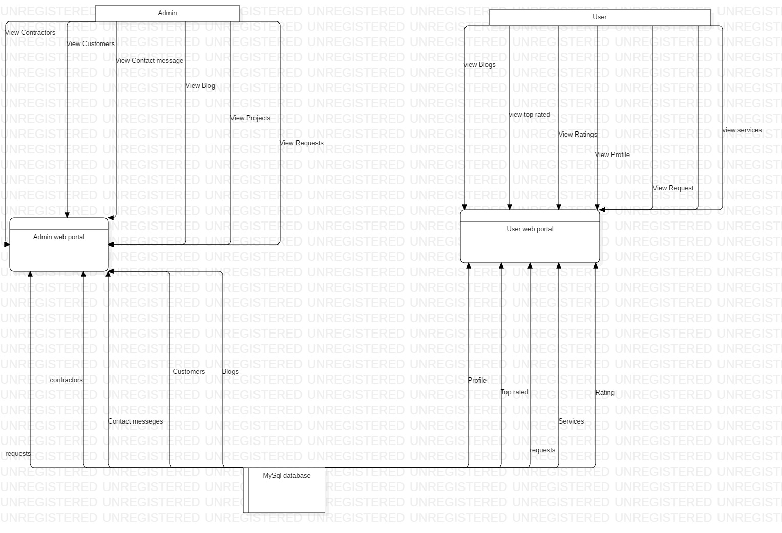

**Figure 4- 1** Data Flow Diagram (Level 0)

## Activity Diagram

Activity diagram is a type of behavioral diagram. We have two actors in our system that perform different actions in the system.

## Admin Activity Diagram:

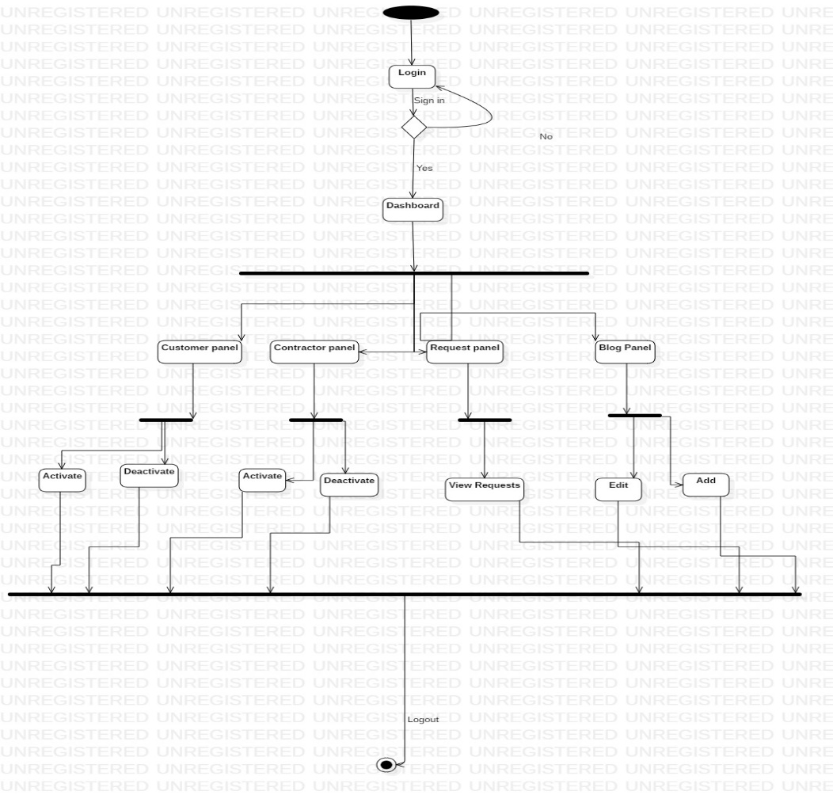

**Figure 4- 2** Admin Activity Diagram

There are activities that are perform by admin while login to the system. In the dashboard Admin perform all these above operations.

## Customer and Contractor Activity Diagram:

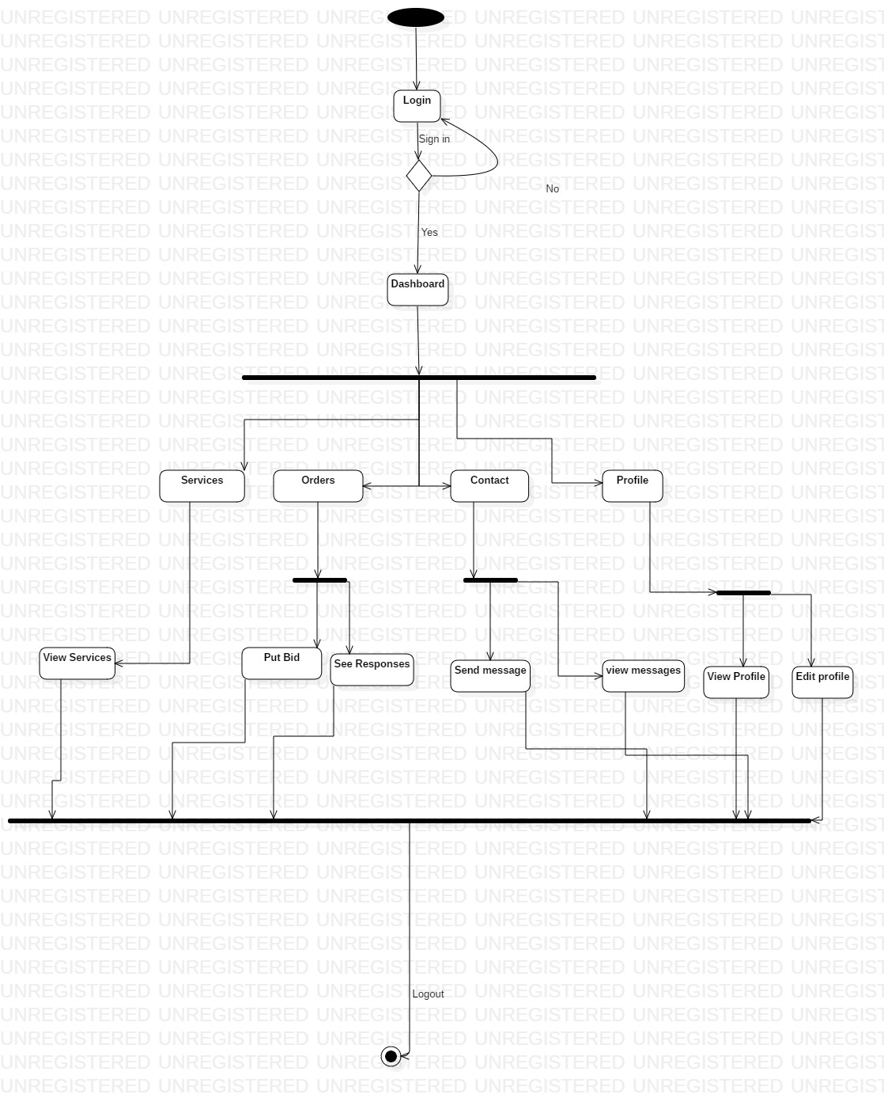

**Figure 4- 3** Customer Activity Diagram

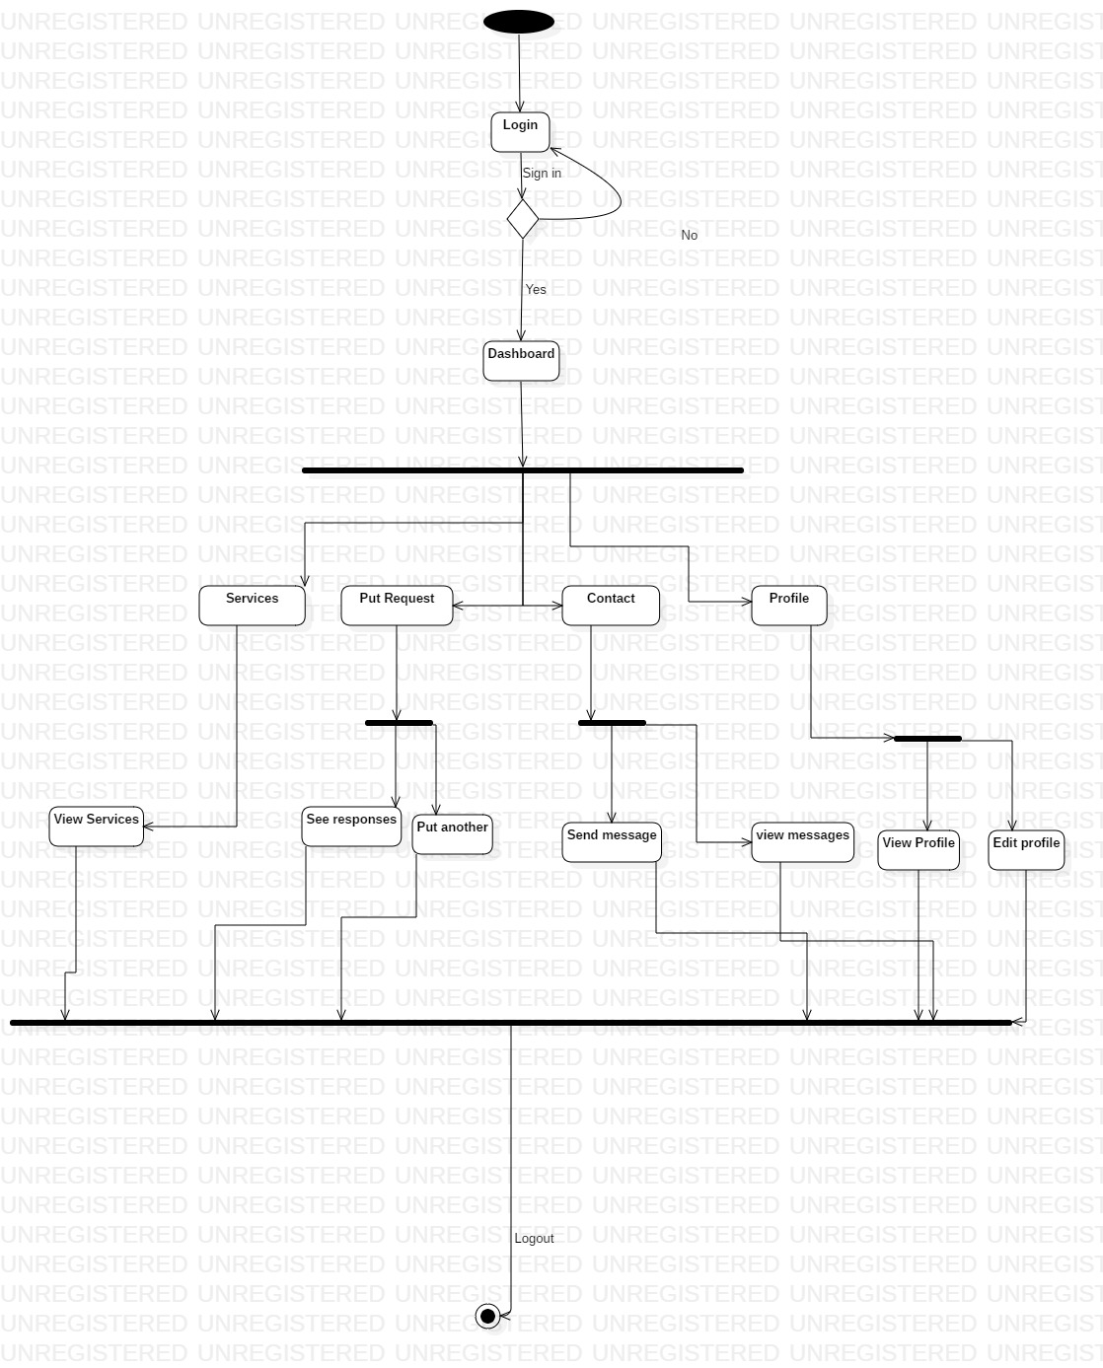

**Figure 4- 4** Contractor Activity Diagram

There are activities that are perform by user while login to the system. In the home page perform all these above operations.

## Class Diagram

This is a type of structural modeling diagram in which classes are populated with each other in terms or relationship.

* Association
* Aggregation
* Composition

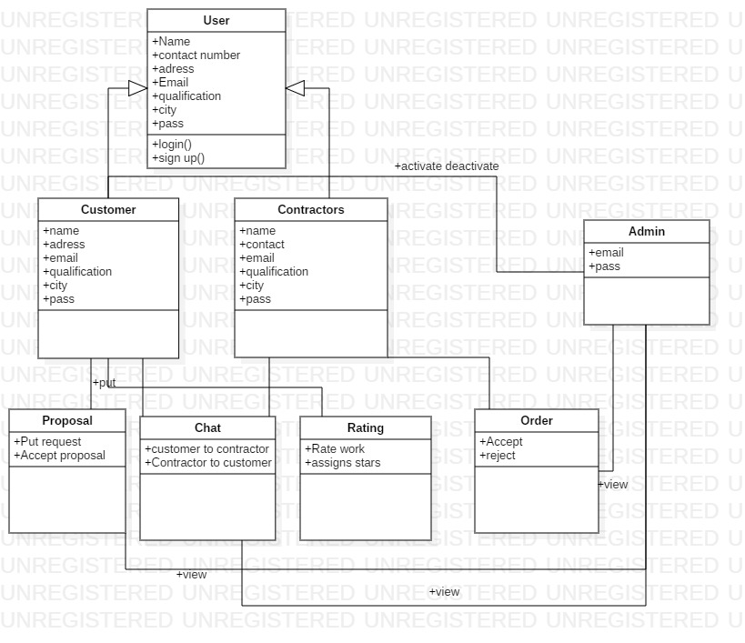

**Figure 4- 5** Class Diagram

## ERD Diagram:

ERD abbreviated as the entity relationship diagram which shows the relation between different tables in database management system, it also show the interaction between entity.

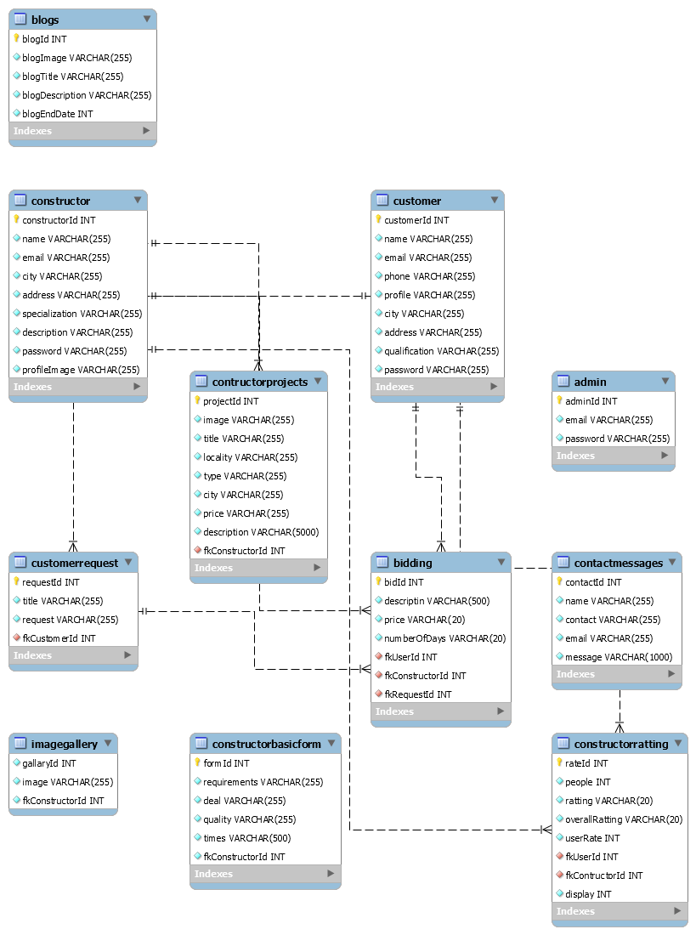

**Figure 4- 6** ER Diagram

# Chapter 5 Implementation

## Implementation

This chapter is the overview of the different tools used in the development of application and the important stages through the development process. For the development of the project “Online 3D Jewelry Shop with Recommender” some of the important implemented stages mention in this chapter and the different tool that are used and that are listed below.

## Tools

* + - XAMPP
    - MYSQL
    - Bootstrap
    - Sublime text

## XAMPP

XAMPP is a free and open-source cross-platform web server solution and it consist of Apache HTTP Server, Maria DB database and interpreter for scripts. Such as we are developing a project, for the website developing we are using XAMPP.

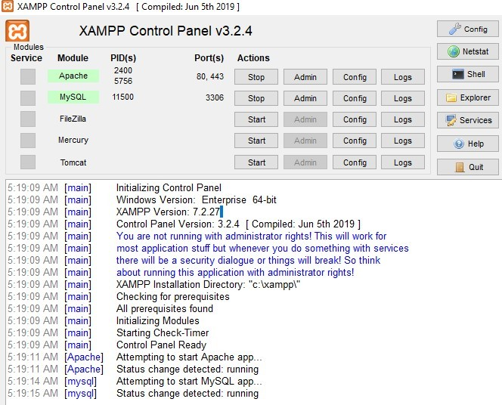

**Figure 5- 1** XAMPP Control Panel

## MYSQL

We are using MYSQL database for our project and this will work when XAMP server will be open just like show in above picture. MYSQL is an open-source relational database management system, because we are developing android and web-based project so that is why we are using relational database.

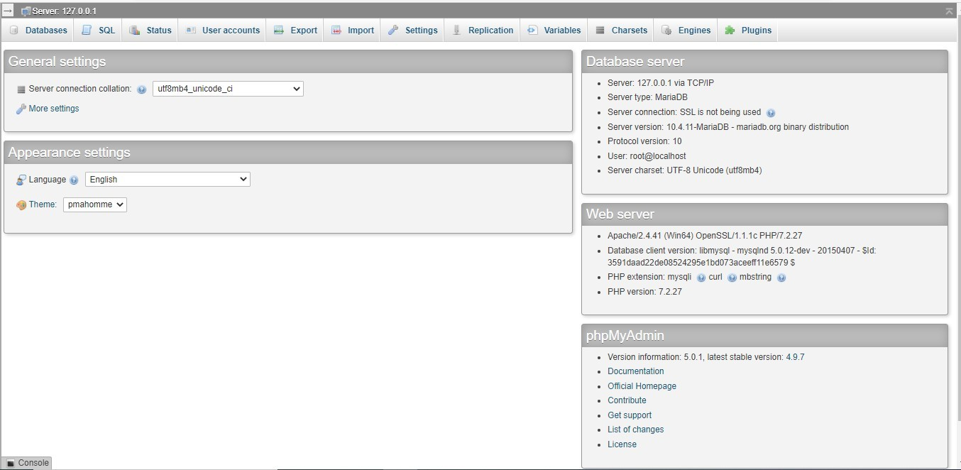

**Figure 5- 2** MySQL

## Sublime text

Sublime Text is a shareware cross-platform source code editor with a Python application programming interface. It natively supports many programming languages and markup languages, and functions can be added by users with plugins, typically community-built and maintained under free-software licenses.



**Figure 5- 3** Sublime

## Development Stages for web portal

The project **Online Construction handling** is developed in no of development stages but some are described below. As our project is web based so firstly, we discuss about Web design. Following were the discrete phases we have experienced incrementally to realize our product in the given time.

## Sign up

If the user is new and can’t have his account then he clicked on signed up button, the page will appear and user have to fill all the options and then they will be able to signed in as customer. In this form all information of user is taken. Validation is applied on email.

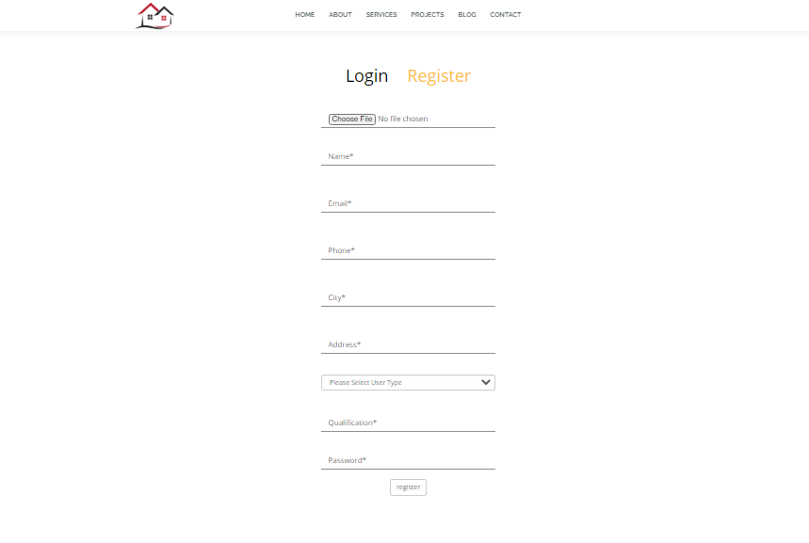

**Figure 5- 4** Sign Up Page

## Login Page

We started the project by creating a web page that is our login page. Firstly, the user has to be signed up and if he already has an account, he enters his email and password and click on Log in button he will allowed to Log in. Login page is same as for admin.

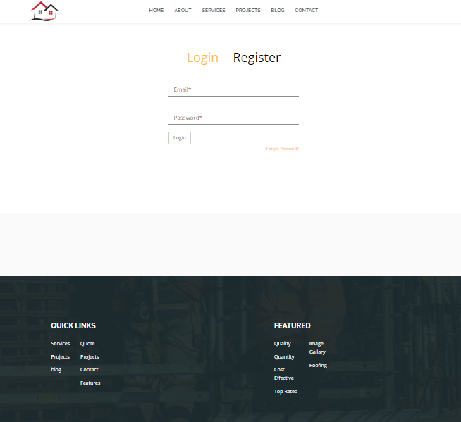

**Figure 5- 5** Login Page

## Forgot Password

If user forgot the password, he will click on forgot password then he will redirect to the page where user add their email and submit it and then login and proceed further.

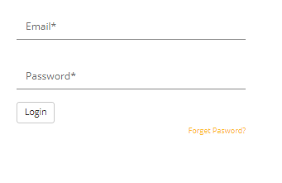

## Home page

**Figure 5- 6** Forget Password

When user will create their own account and account is verified the user can view home page. On the home page main pages are displayed. All categories of construction item are also shown on this page.

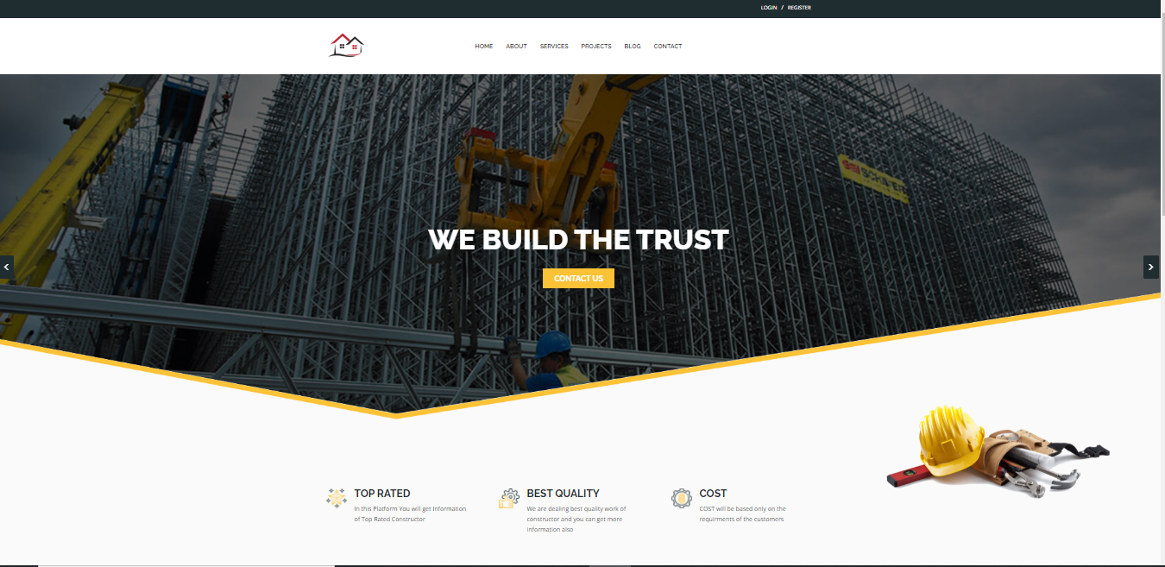

**Figure 5- 7** Home Page

## About Us

About us page contain information of our website. When user click on Shop Now, he will redirect to homepage.

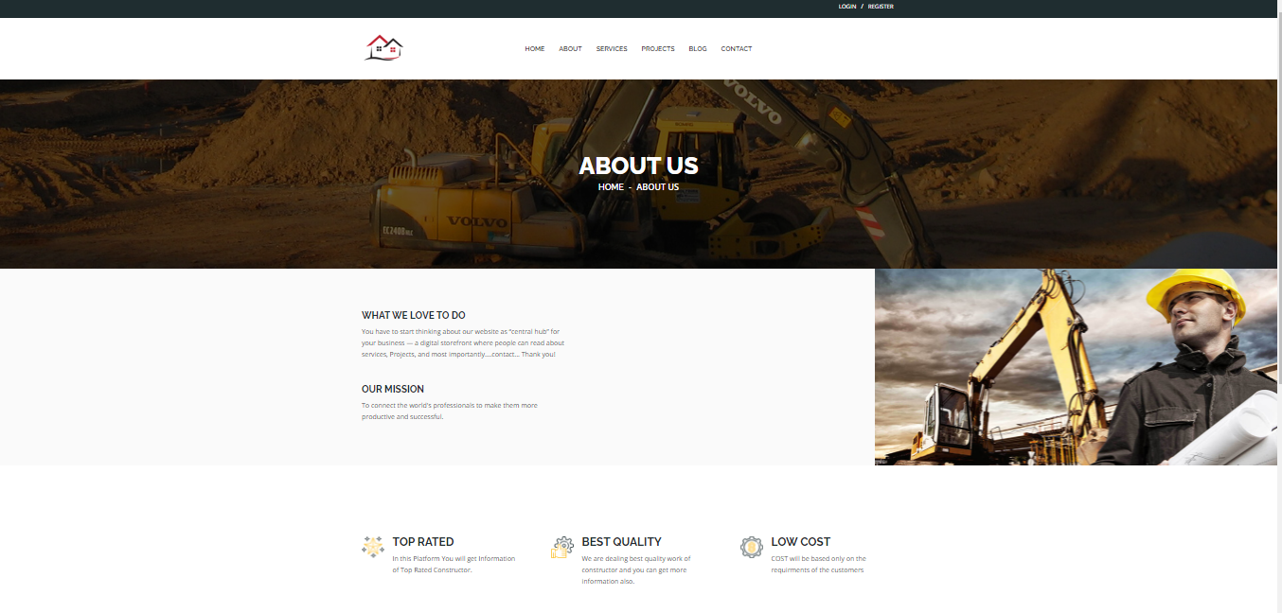

## Contact Us

**Figure 5- 8** About Us Page

If user wants to give any suggestions or user have any issue he can contact with admin through contact us page. We also add the validation in every inputs.

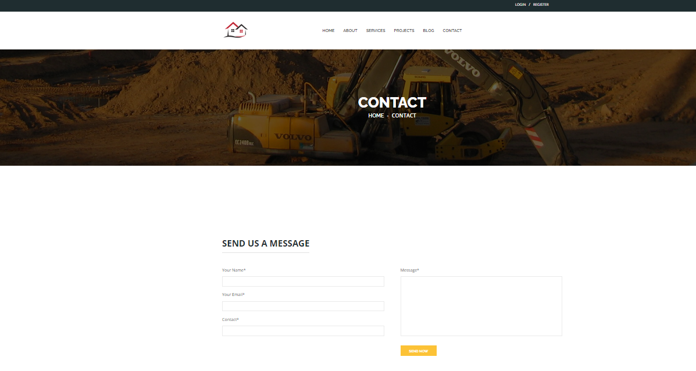

## Top Constructor page:

**Figure 5- 9** Contact Us Page

The contractors that are mostly viewed by the user.

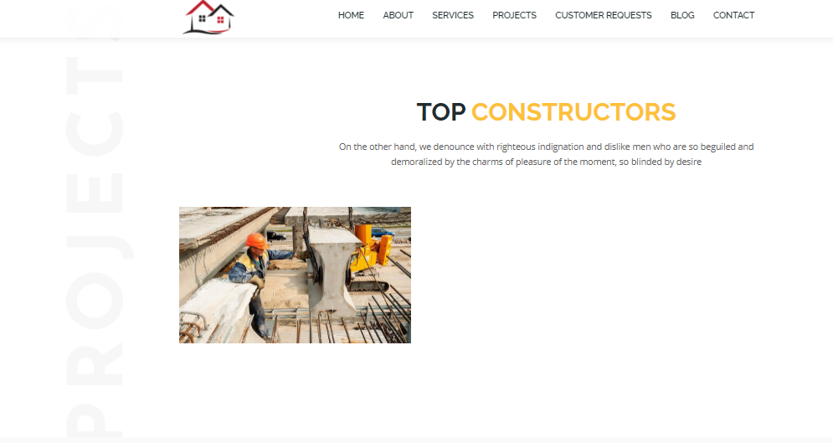

**Figure 5- 10** Top Constructor Page

## Customer Request

Contractor can see the requests

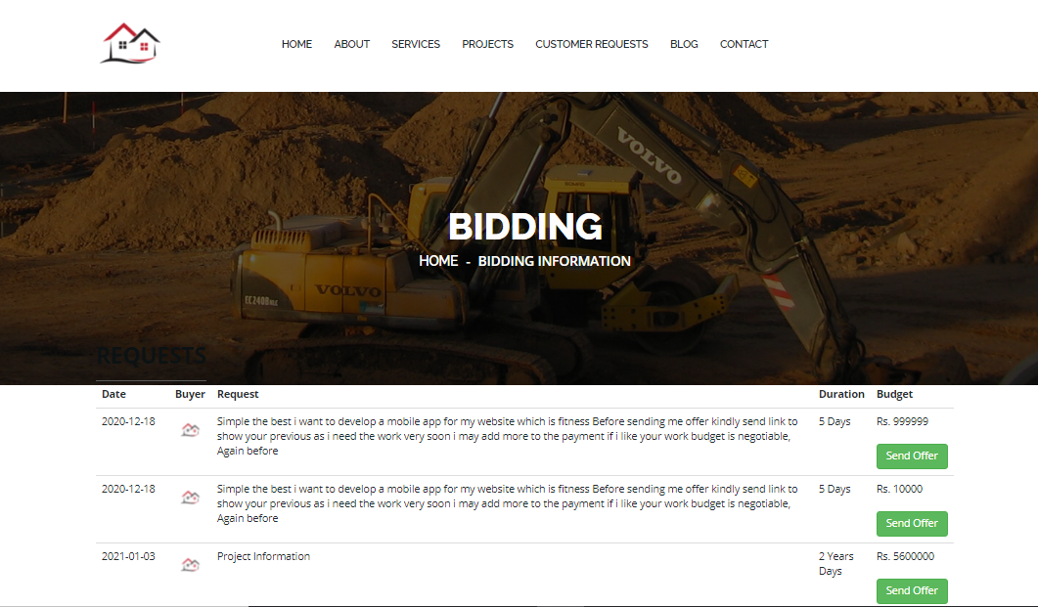

**Figure 5- 11** Customer request

## Send Order

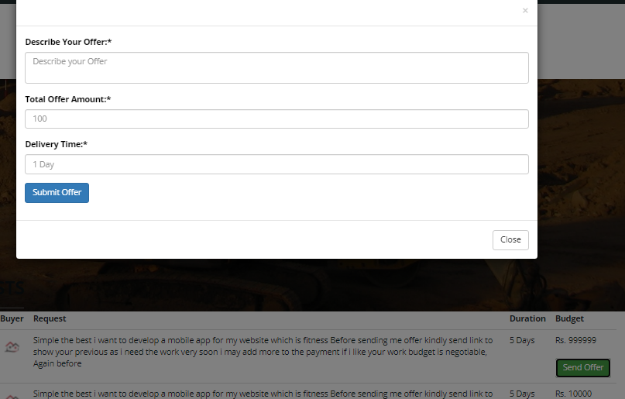

## View projects

**Figure 5- 12** Send order

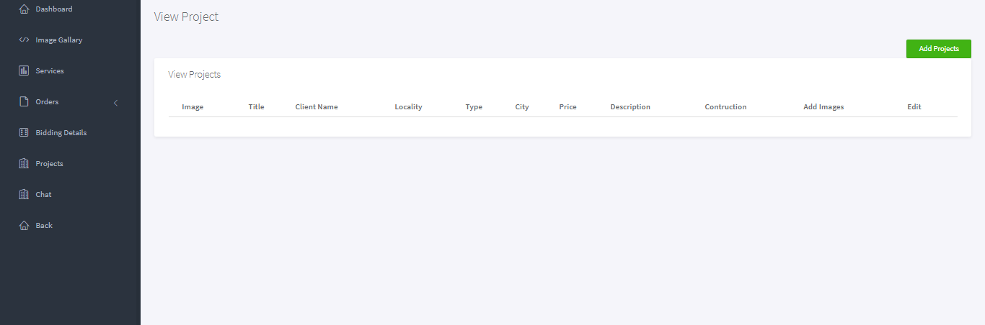

**Figure 5- 13** View projects

## Contractor Account

**Figure 5- 14** Contractor Account

## Admin Login

Admin will enter his email and password to login.

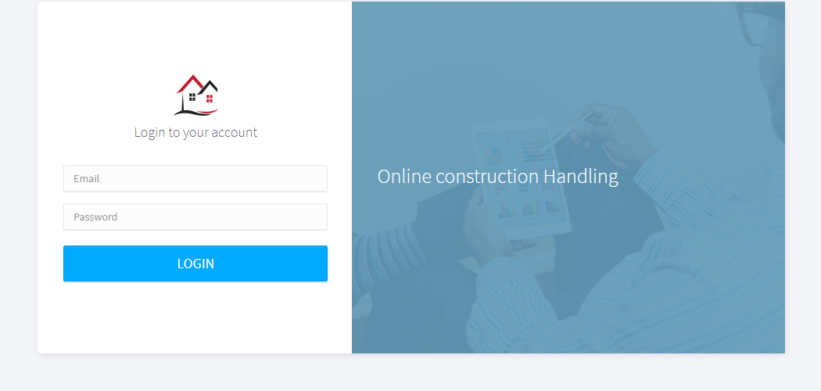

**Figure 5- 15** Admin Login Page

## Contractor Dashboard

After login admin view the dashboard where it can see the overall view of the products, orders, messages.



## Put request

**Figure 5- 16** Contractor Dashboard

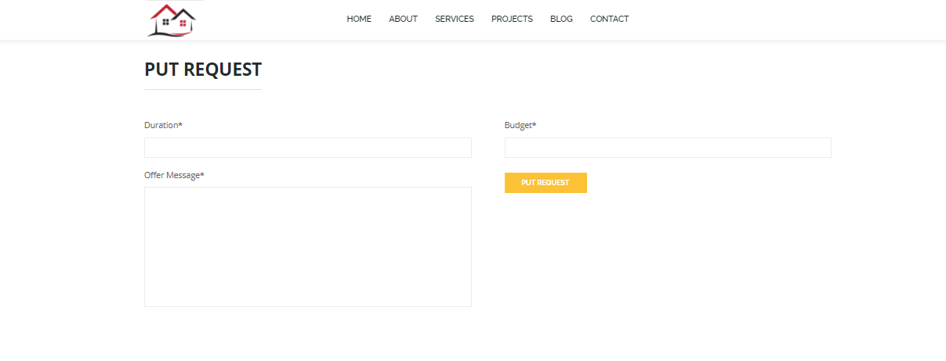

**Figure 5- 17** Put request

## Orders

Contractors view the orders.



**Figure 5- 18** Order View Page

## Getting Ratings from the users:

We get the ratings from the users of every product along with the reviews. We cannot restrict our user to add ratings, user have own choice but for user must be login or register their self in the system to add the rate to any contractor. We also show the reviews of other users to help the user to buy the product or not if they are new to our website.

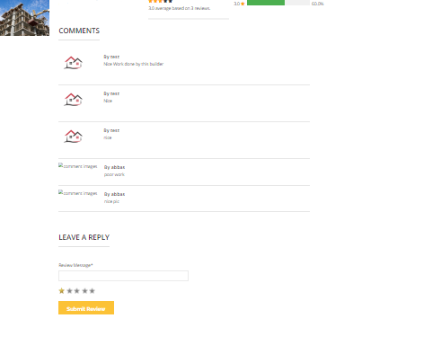

**Figure 5- 19 User’s** review and rating

## 

## 

## Store rating in the database tables

After user add rating in any product that record will be store in the database to used it further for the recommendation. We store the following information of every user in the database: reviews, total reviews, people (how many reviews in total), review message.

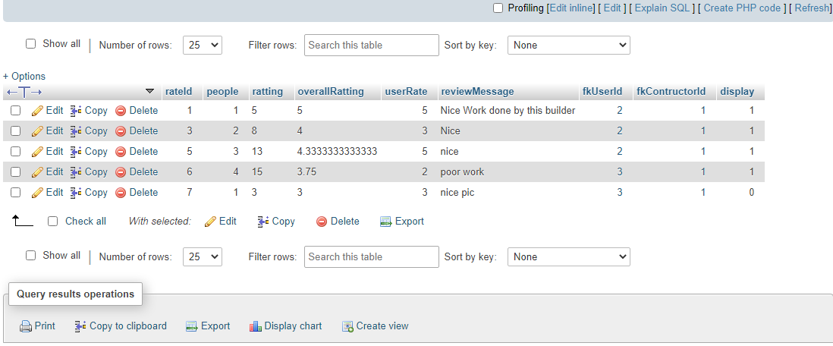

**Figure 5- 20** Store rating in the database tables

# CHAPTER 6 SYSTEM TESTING

## System Testing

In system testing a complete and integrated system is tested. Our focal point throughout the designing and implementation was to test each unit. User activities regarding with user’s registration properly tested and stored in database. Validation and verification are very important process where we will validate each module in case if user enter any wrong entry in desired field.

## Unit Testing

IT’S a level where we test each individual component while being developed for the conformance to desired requirement. This testing was applied to both login and registration portions in case if our user enters some incorrect value then a message will be shown to put correct entry. We applied validation process on our input field. we also check the conformance of correct value to be entered in database.

## System Testing

We have focused on thorough testing through-out the design and implementation phase while testing the user and admin all the other activity that they perform should be stored in database. Evaluation contains the testing of each and every module of the system and checking the errors which occur into the database while putting some entries into it or the interface problem.

|  |  |  |  |  |  |
| --- | --- | --- | --- | --- | --- |
| Steps | Actions | | Expected  Response | System | Pass/Fail |
| 1 | Users enter email | Invalid | Show error message “Please enter valid  email. | | Fail |
| 2 | User enter password. | invalid | Show error message “Please enter valid  password | | Fail |
| 3 | Enter valid password. | |  | |  |
| 4 | Users click on login button | | System displays the home page of profile  setting. | | Pass |

|  |  |  |  |
| --- | --- | --- | --- |
| **Steps** | **Action**  **s** | **Expected System Response** | **Pass/fail** |
| 1 | Click on sign up button. | System displays a registration form | Pass |
| 2 | Users enter the invalid  Email. | System shows error message “Email invalid”. | Pass |
| 3 | User enters the password all in lower case | System shows error” Password must contain at  least one upper case character and 8 characters of total” | Pass |
| 4 | User Enter same contact. | System shows “contact already exist” | Pass |
| 5 | Users enter number in  name field. | System shows error “Please Enter correct  name” | Pass |
| 6 | User Click on Sign up  button | System shows error “One or more field is  missing or incorrect” | Pass |

|  |  |  |  |
| --- | --- | --- | --- |
| **Steps** | **Actions** | **Expected System**  **Response** | **Pass/Fail** |
| 1 | Admins enter Invalid email | Show error message  “Please enter valid email. | Pass |
| 2 | Admin enter invalid password. | Show error message “Please enter valid password | Pass |
| 3 | Enter valid password. | System shows login successful | pass |
| 4 | Admin clicks on login  button. | System displays the  home page of profile setting. | Pass |

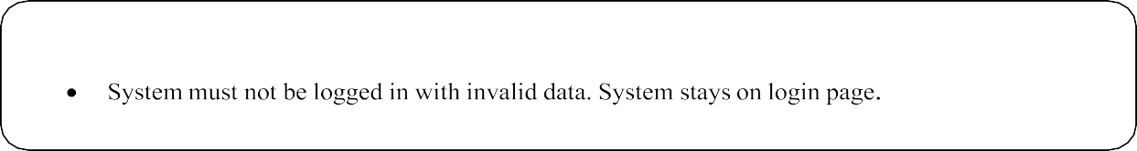

|  |  |  |  |
| --- | --- | --- | --- |
| **Steps** | **Action**  **s** | **Expected System Response** | **Pass/fail** |
| 1 | Click on sign up button. | System displays a registration form | Pass |
| 2 | Admin enter the existing | System shows error message “Email  already exist”. | Pass |

|  |  |  |  |
| --- | --- | --- | --- |
| 3 | Admin enters the 9  character password. | System shows error” Password must be at  least 9 character” | Pass |
| 4 | Admin enter invalid Email  format/ same email. | System shows “Email already exist” | Pass |
| 5 | Admins enter number in  name field. | System shows error “Please Enter correct name” | Pass |
| 6 | Admin Click on Sign up Button. | System shows error “One or more field is  missing or incorrect”. | Pass |

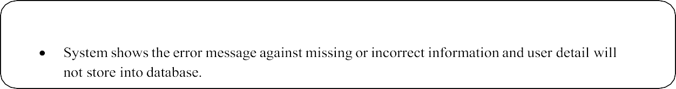

|  |  |  |  |
| --- | --- | --- | --- |
| **Steps** | **Action**  **s** | **Expected System Response** | **Pass/fail** |
| 1 | Click on activate  button. | System activates the user. | Pass |
| 2 | Admin click on deactivate button.  . | System deactivates the user or the contractor. | Pass |
| 3 | Admins enter into blog field.  . | System shows “Edit or add blog” | Pass |
| 4 | Admin Click on add Button. | System shows error “One or more field is missing or incorrect”. | Pass |

|  |  |  |  |
| --- | --- | --- | --- |
| **Steps** | **Action**  **s** | **Expected System Response** | **Pass/fail** |
| 1 | Click on forgot  password button. | System displays a form. | Pass |
| 2 | Admin enter the email that registered  is address. | System shows error “Enter correct email address. | Pass |

# Chapter 7 Conclusion and Future Work

## Conclusion and Future Work

In this project we developed a web-based system “Online Construction Handling”. It is very useful application as online work is getting better day by day. Now a days everyone wants to work and handle things from his home and laptop. So, we provided them opportunity in the field of construction. Its difficult for a person who want things related to construction to go out and search contractors. Also, difficult to discuss rates or find better pricing for his work. Solving this problem our website provides them opportunity to see blogs, contractors, projects, and ideas about the construction. They can easily post their requirements and can get different contractors request on the post. After, they can choose the best price and the contractor for themselves. They can also rate the work of the contractors. The user on our website can also send his queries to the admin, so he can resolve their problems.

## Future Work

There could be some improvement possible in this website. Some of the improvements for future development are mentioned below:

## Website

We will add other products as construction materials in our website. We aim to provide online payment methods and mobile app to the user so they can easily handle the payments online. We also aim to provide the customer more functionalities like searching different products related to construction, buying them and getting those at their doorstep. Moreover, there are a lot of ideas we aim to bring them to the website so it can become a better market place for both customer and contractors.

# Chapter 8 References

### References

1. Unknown, “Website | Definition of Website by Merriam-Webster,” *Merriam-Webster Dict.*, 1993.
2. R. Pressman, *Software engineering: a practitioner’s approach*. 2005.
3. S. Ambler, “Technical (Non-Functional) Requirements: An Agile Introduction,” *Agil. Model.*
4. G. Sparks, *Database Modeling in UML*. .
5. https://developers.google.com/web/updates/2019/02/model-viewer
6. http[s://www.polymer-project.org/](http://www.polymer-project.org/)
7. https://www.youtube.com/watch?v=wkSA9bfCmKU&list=PL0b6OzIxLPbz1cgxiH5KCBsyQij1HsPtG
8. https://[www.youtube.com/watch?v=314m7YBRFvQ&list=PL6n9fhu94yhXd4xnk-](http://www.youtube.com/watch?v=314m7YBRFvQ&list=PL6n9fhu94yhXd4xnk-) j5FGhHjUv1LsF0V

[9] https://developers.google.com/machine-learning/recommendation/collaborative/basics [11] [10] https://link.springer.com/chapter/10.1007/978-3-540-72079-9_9

[11] http[s://www.geeksforgeeks.org/user-based-collaborative-filtering](http://www.geeksforgeeks.org/user-based-collaborative-filtering)

1. https://en.wikipedia.org/wiki/Sublime

### Plagiarism Report:

